***SAVE THE DATE***

**North Country Fire Mutual Aid District**

**is proud to offer**

**“Pride & Ownership and Five Alarm Leadership”**

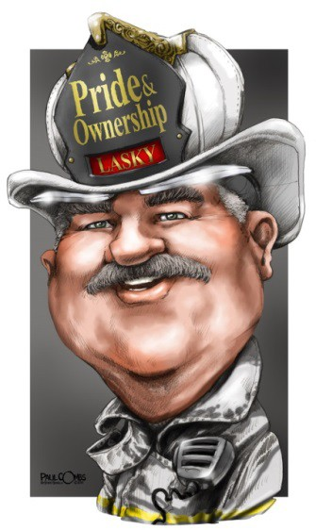

**When: September 12, 2015 Where: White Mountain Regional High School**

**127 Regional Road, Whitefield, NH**

**Chief Rick Lasky (ret.)** a 34-year veteran of the fire service, served as chief of the Lewisville (TX) Fire Department for 12 years, prior to that as Fire Chief in Coeur d'Alene Idaho. Rick followed in his father’s footsteps beginning his career as a firefighter in the suburbs on the southwest side of Chicago and while in Illinois received the 1996 International Society of Fire Service Instructors “Innovator of the Year” award for his part in developing the *“Saving Our Own”* program. Throughout his 30-plus years in the fire service he has served as a career and volunteer firefighter. He served as the co-lead instructor for the H.O.T. Firefighter Survival program at FDIC for over 10 years, is a long-standing editorial advisory board member for *Fire Engineering Magazine* and also serves on the *FDIC* advisory board. Rick is the author of the best-selling books *“Pride and Ownership-A Firefighter’s Love of the Job”* and *“Five Alarm Leadership: From the Firehouse to the Fireground”* published by *PennWell Books* and is the co- host for the radio show “The Command Post” heard on *Fire Engineering Talk Radio*. Rick holds an AAS Degree in Fire Science from Columbia Southern University and was selected as the CSU 2012 Distance Education and Training Council (DETC) Outstanding Graduate. He was also honored in 2011 as an inductee into the Chicago Softball Hall of Fame.